<https://bohanhyland.ie/wp-content/uploads/2019/02/logo-outline.png>

<https://bohanhyland.ie/>

Power outage ESB:

<https://powercheck.esbnetworks.ie/>

The idea for this project came from my partner, he works in a property management company called Bohan Hyland (<https://bohanhyland.ie/>), the bock and facility management section is the department that he works and he gave some suggestions of functions that would help him and his team. Some of these suggestions are:

* A page where the registered user would be able to order keys and fobs

He informed that their website needed to be improved. It was not updated for at least 10 years and the “bock and facility management section” section would benefit them if there was a member area where members could log in and order new keys and fobs. At the moment these orders are made via email and his idea was to have a shopping cart on the website.

Here was one of their competitors he mentioned as an example of good layout: <https://www.owenreilly.ie/>

Requirements:

* Improve their website, making it looking more modern
* Remove the box around their logo
* Include a “member portal” section to the “OMC Block Management” section

After hearing the ideas, my first step was to create the html pages that I knew we would need and start from them. More pages to be added later if necessary. These are the pages:

1. Home Page (index.html)
2. About Us
3. Members Portal
   * Register
   * Login
   * Order
4. Contact Us (contact.html)
5. Services
   * Residential Sales
   * Lettings

Navigation Bar

* I followed the “Navbar Bootstrap 5 | Bootstrap Navbar Tutorial” (link in the reference section) to create a nav bar using bootstrap, including the drop-down in the nav bar
* The color rgb(33,67,156) is the color of the logo background color. I used the color picker using inspector in chrome. After I got the rgb equivalent, I added **style="background-color:rgb(33, 67, 156)** to the nav tag

Contact Page (contact.html)

* I decided to use the Modal bootstrap button, as it opens a confirmation pop-up window once the message is sent. It has a nice layout. I made the necessary changes to work the way I wanted
  + I removed the “save changes” button
  + I used the **class="btn btn-primary"** for the close button

For styling, I decided to user Bootstrap. The focus of this project is JavaScript, using bootstrap for layout would allow me to create a layout quickly to be used on all pages without the need to have a .css file on my project. To use Bootstrap, I added the two lines below to my page headers, as per instructed on the bootstrap page:

<link href="https://cdn.jsdelivr.net/npm/bootstrap@5.3.3/dist/css/bootstrap.min.css" rel="stylesheet" integrity="sha384-QWTKZyjpPEjISv5WaRU9OFeRpok6YctnYmDr5pNlyT2bRjXh0JMhjY6hW+ALEwIH" crossorigin="anonymous">

<script src="https://cdn.jsdelivr.net/npm/bootstrap@5.3.3/dist/js/bootstrap.bundle.min.js" integrity="sha384-YvpcrYf0tY3lHB60NNkmXc5s9fDVZLESaAA55NDzOxhy9GkcIdslK1eN7N6jIeHz" crossorigin="anonymous"></script>

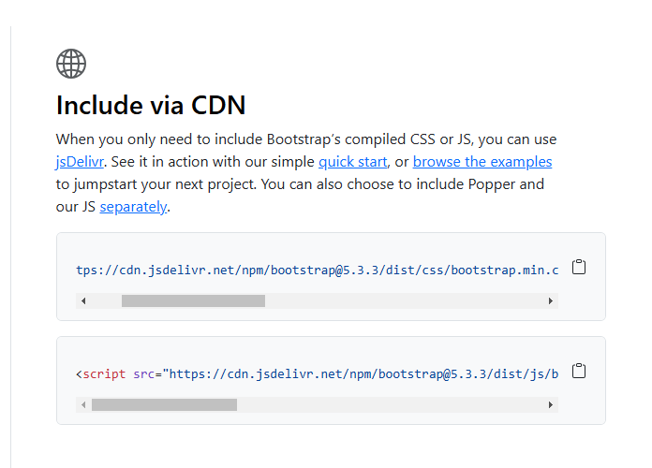

Github

Repository: <https://github.com/gustavowmarques/bohanhyland.git>

I had issues committing new changes from visual studio

I was committing and pushing a change and I noticed that “master” branches were being created:

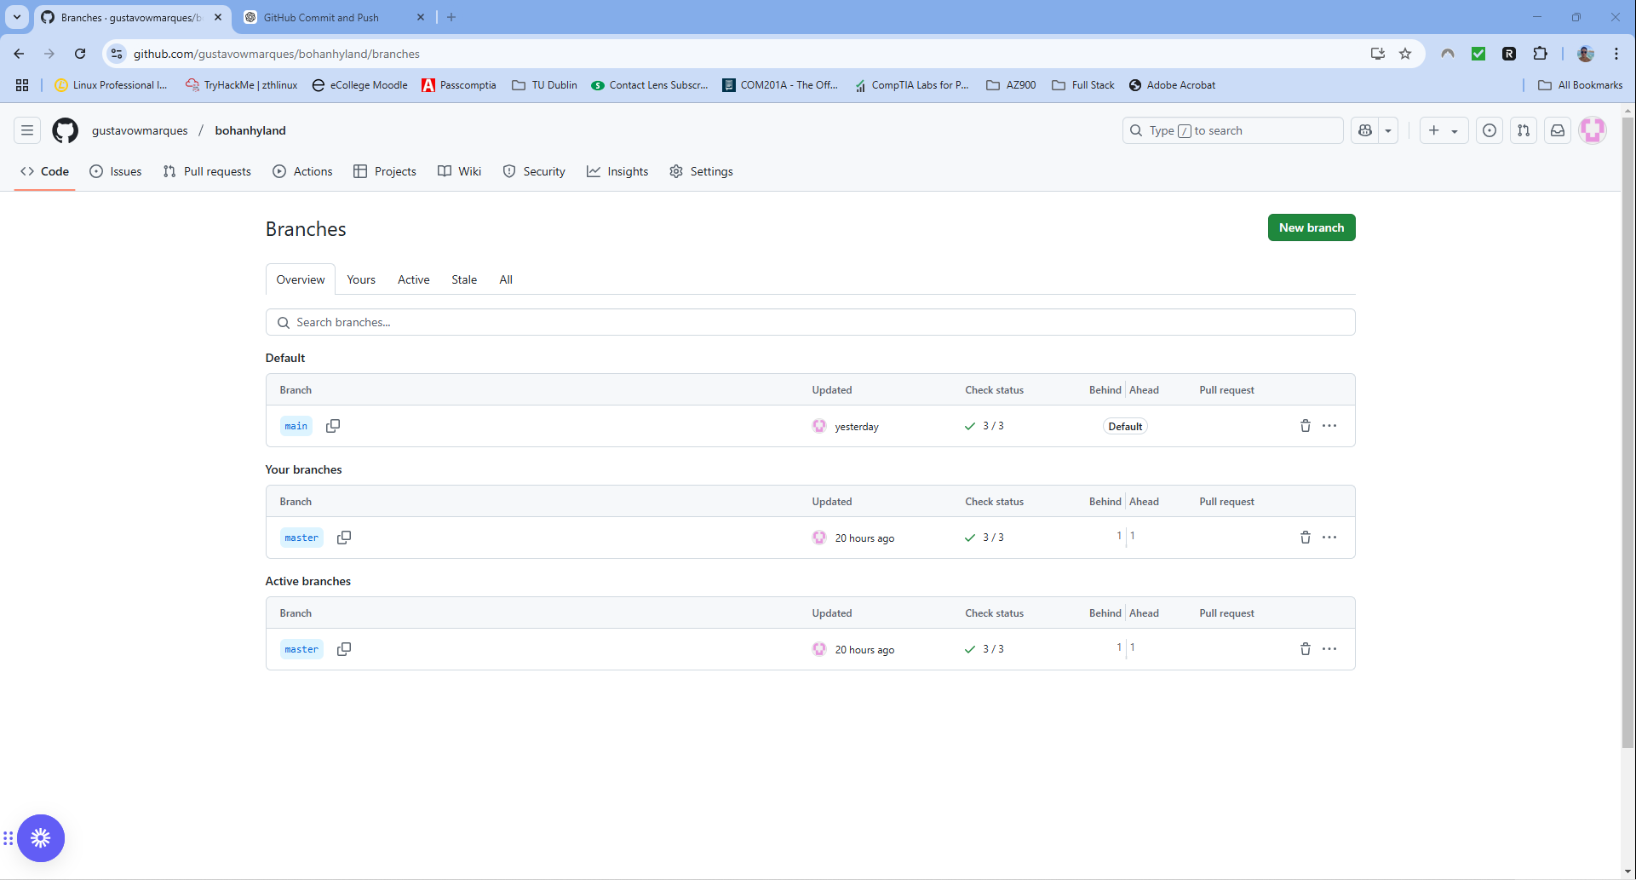

I used Chat GPT to help me to merge everything into 1 branch and delete the others.

Everything is now within the branch named “main”

References:

<https://www.youtube.com/watch?v=eow125xV5-c>

<https://getbootstrap.com/>

https://getbootstrap.com/docs/5.3/components/modal/